**Write a shell script to sort an array of numbers using any sort method.**

#!/bin/bash

echo "enter number of elements in array"

read n

echo "enter Numbers in array:"

for (( i = 0; i < $n; i++ ))

do

read nos[$i]

done

for (( i = 0; i < $n ; i++ ))

do

for (( j = $i; j < $n; j++ ))

do

if [ ${nos[$i]} -gt ${nos[$j]} ];

then

t=${nos[$i]}

nos[$i]=${nos[$j]}

nos[$j]=$t

fi

done

done

echo -e "\nSorted Numbers "

for (( i=0; i < $n; i++ ))

do

echo ${nos[$i]}

Done

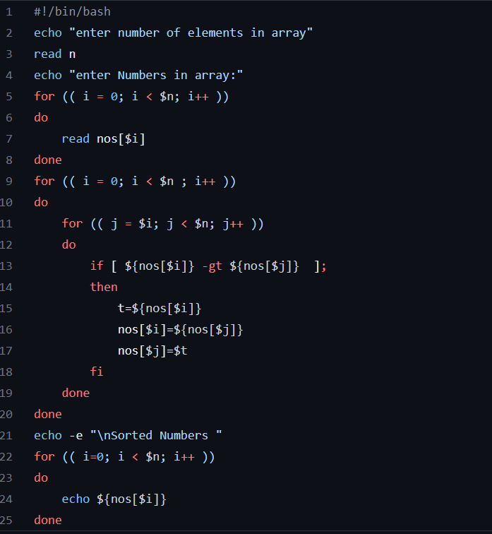

Write a shell script to check and count occurrence of a sub-string in the given string using command line arguments.

#!/bin/bash

string="Hello, world! This is a test string."

echo "The given string is: $string"

echo "Enter a substring:"

read substring

count=$(echo "$string" | grep -o "$substring" | wc -l)

echo "The substring '$substring' appears $count times in the string '$string'."

**Write a Shell script to check whether given number is prime or not. Also print the reverse of the given number.**

#!/bin/bash

echo "enter a number"

read n

for ((i = 2;i<=$n/2;i++))

do

ans=$((n%i))

if [ $ans -eq 0 ]

then

echo "$n is not a prime number."

exit 0

fi

done

echo "$n is a prime number."

#!/bin/bash

echo "enter a number"

read n

num=0

temp=$n

while (($temp>0))

do

k=$((temp % 10))

num=$((num * 10 +k))

temp=$((temp / 10))

done

echo "$num is reverse of $n."

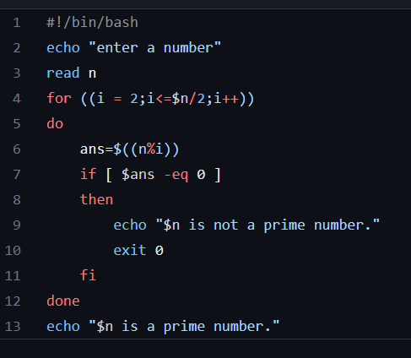

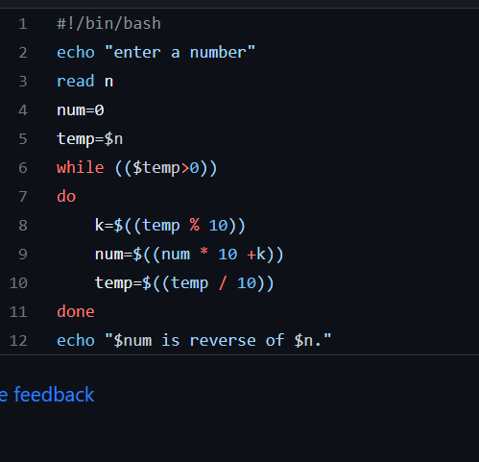

Write a Shell script to check whether given number is palindrome or not. Also print the reverse of the given number.

#! /bin/bash

echo "Enter a Number";

read n

temp=$n

while ((temp>0))

do

ans=$((ans*10))

mod=$((temp%10))

ans=$((ans+mod))

temp=$((temp/10))

done

if (($n == $ans))

then

echo "$n is a Palindrome Number"

else

echo "$n is not a Palindrome Number"

fi

echo "Reverse of $n is $ans"

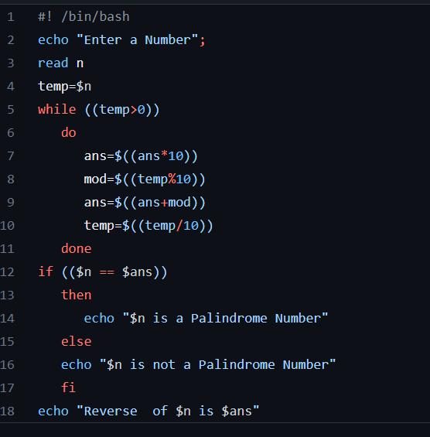

Write a Shell script to find the Factorial of given number using Recurrence Method and Without Recurrence Method (Both way)

#!/bin/bash

factorial(){

product=$1

if((product <= 2)); then

echo $product

else

f=$((product -1))

f=$(factorial $f)

f=$((f*product))

echo $f

fi

}

echo "Enter the number:"

read num

if((num == 0)); then

echo 1

else

factorial $num

Fi

echo "Enter a number"

read num

factorial=1

for((i=2;i<=num;i++)){

factorial=$((factorial * i))

}

echo $factorial

